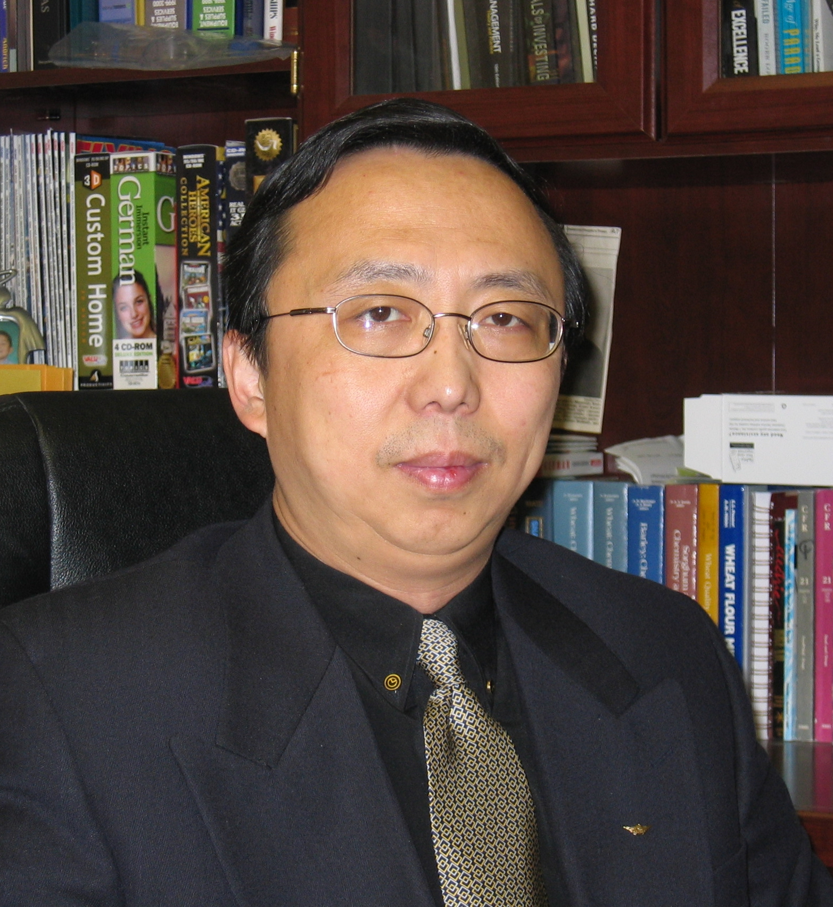
Laurence Lee, Ph.D./MBA
President/CEO, LZL Engineering, LLC,
Owatonna MN USA

Following his early education in China earning a M.S./B.S. in Agricultural Engineering, Laurence attended Laval University (Qc., Quebec, Canada) for his doctoral study (1994) in food science and technology. He also earned a MBA degree (2002) from the University of St. Thomas (Minneapolis MN) while employed in the food industry. Laurence has extensive experience in industrial research and development of food processing/packaging, bioconversion and separation technologies; while his latest focus has been on innovation of fluidized bed technologies for special particle processing and applications. Laurence is a well known fluid bed expert for food ingredients and beverage agglomeration, nationally and internationally.

Over the years, Laurence has excelled in numerous positions for leading industry research and development: Principal Scientist, Dir. R&D, VP Technologies, CTO, COO and Executive Consultant. He has contributed to numerous new product developments and commercializations. His current venture is with LZL Engineering. His presentation will share some reflections and experience in industry research and business development.

